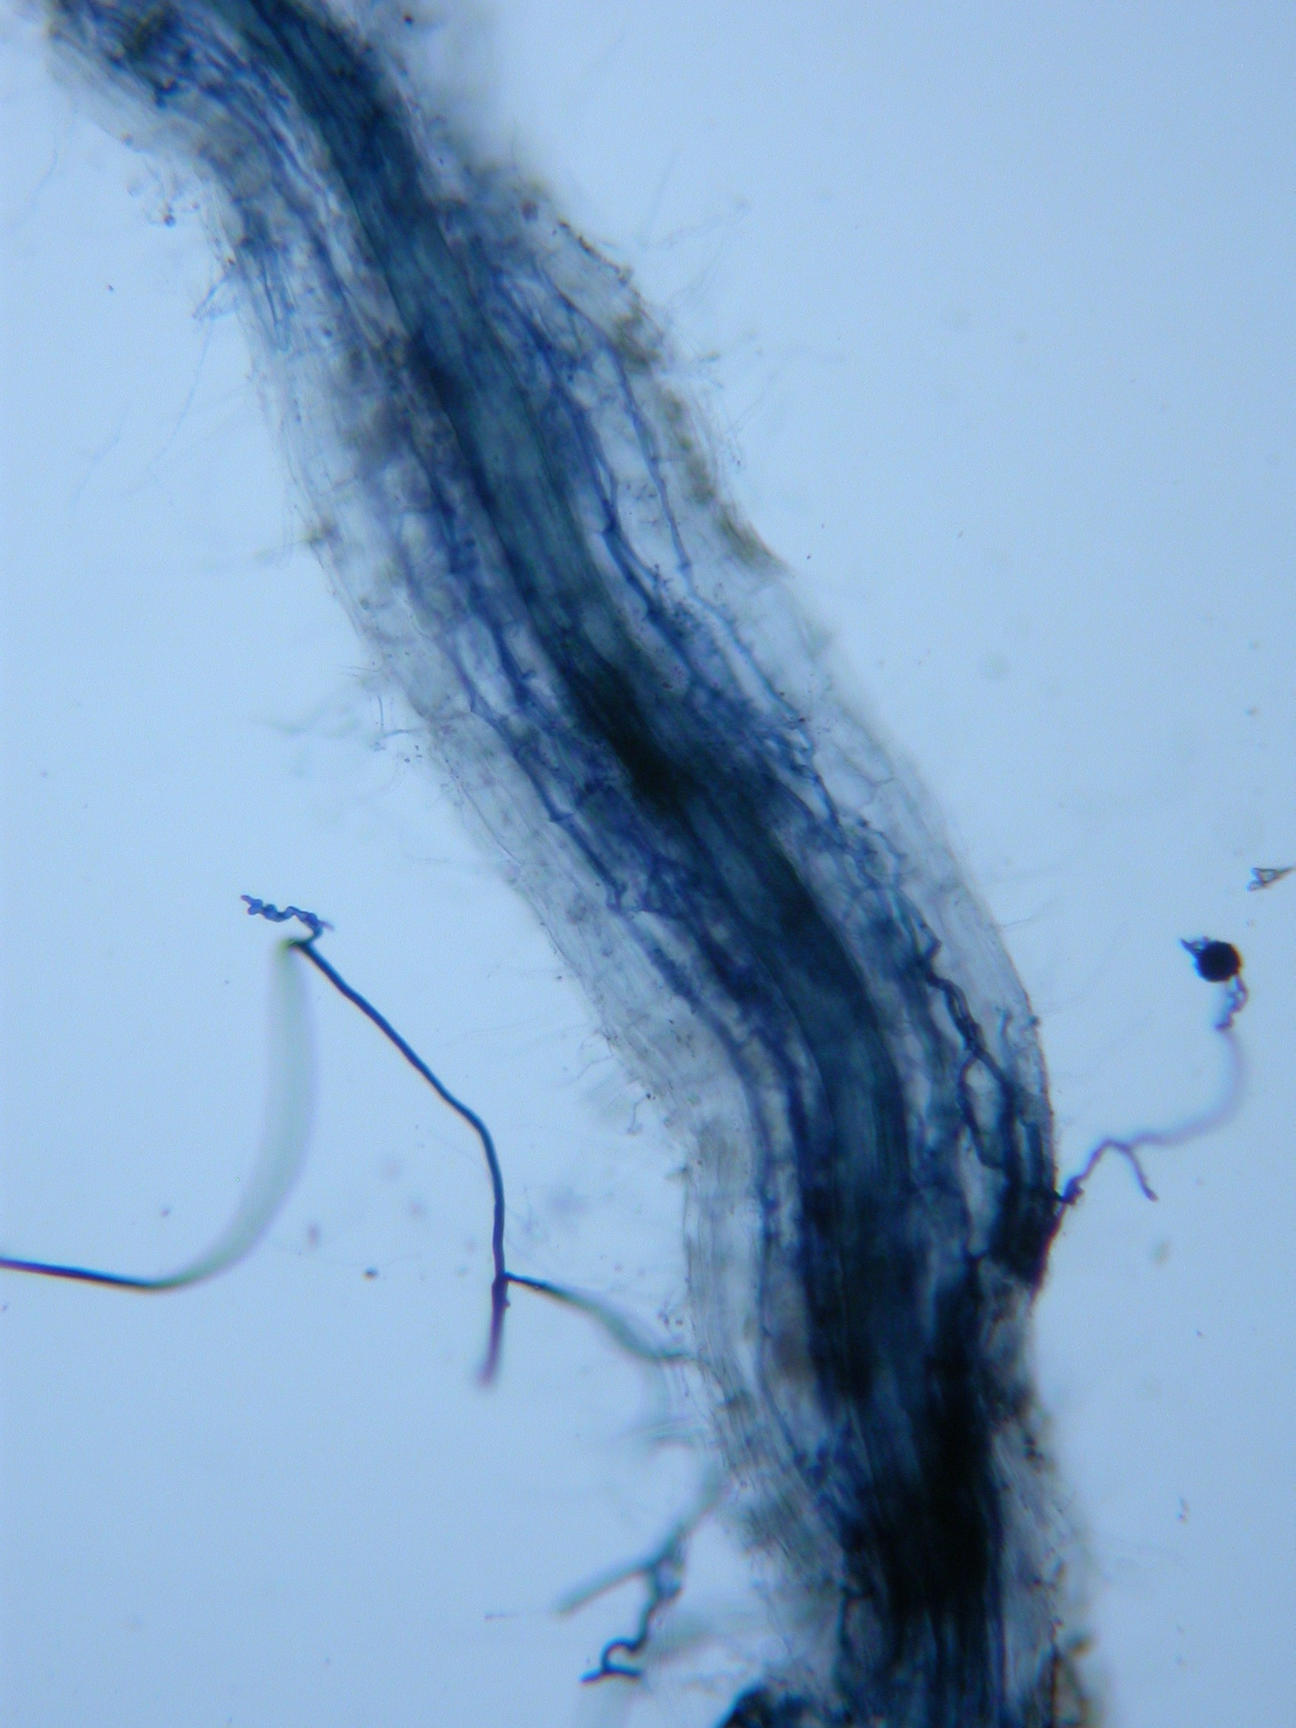
Narbacular Drop

Game Design Document

Nuclear Monkey Software

DigiPen Institute of Technology
GAM400-B F04 Version 1.0
09/17/04
Instructor: Michael Moore

Table of Contents

1. Introduction 3
1.1 High Concept 3
1.2 Target Demographic 3
1.3 Target Platform 3
1.4 Purpose 3
1.5 Minimum System Requirements 4
1.6 Project Risks 4
1.7 Product Competition 4
1.7.a Adventures of Lolo 4
1.7.b Stretch Panic 4
1.7.c Legend of Zelda: The Windwaker 4
1.7.d Ico 4
1.8 Example of Play 5
1.9 Manpower Allocation 5
1.10 Technical Features 5
1.11 Milestone List and Budget 6
1.11.a Milestone List 6
1.11.b Budget 6
2. Story 7
2.1 Setting 7
2.2 Characters 7
2.3 Plot 8
3. Game Mechanics 8
3.1 General Mechanics 8
3.1.a Room Progression 8
3.1.b Player Death 8
3.1.c Saving 8
3.1.d Hints 8
3.1.e Player Movement 8
3.2 Controls 9
3.2.a Cameras 9
3.2.b Walking 9
3.2.c Creating Portals (most details occur in section 3.3) 9
3.2.d Menu Controls 10
3.3 Portals 10
3.3.a Properties 10
3.3.b Practical Uses 10
3.3.c Limits 10
3.3.d Conventions 10
3.4 Game Tasks 11
3.5 Impy Mode 11
3.5.a Overview 11
3.5.b Block stealing 11
3.5.c Portal Blocking 11
3.5.d Wall Climbing \ maneuverability 11
3.5.e Reverse Button Pushing 11
3.6 Game Objects 12
3.7 Menus 13
3.7.a Main Menu 13
3.7.b Level Select 13
3.7.c In Game/Pause 13
3.7.d Configure Menu 13
3.8 Room Outline 15
3.8.a Polishing Up 15
3.8.b Boulder Dash 16
3.8.c Hallway to Hell 17
3.8.d Ledge Ladder 18
3.8.e Fire With Fire 19
4. Descriptions 20
4.1 3D Models 20
4.1.a No-Knees 20
4.1.b Wally's Mouth 20
4.1.c Demon 20
4.1.d Lava Turtle 21
4.1.e Impy 21
4.1.f Metal Crate 21
4.1.g Button 21
4.1.h Boulder 22
4.1.i Wall Torch 22
4.2 Textures 22
4.2.a Room Geometry 22
4.2.b Particles 23
4.3 Audio 23
4.3.a Music 23
4.3.b Sound Effects 23
4.4 Special Sequences 24
4.4.a Credits 24
5. Sign-Off 25

1. Introduction

1.1 High Concept
Help a princess escape an evil wizard by using magic portals that open doorways thorough a trap filled dungeon.

1.2 Target Demographic
This game's simplicity will attract kids to young adults who casually download and play short 30 minute games. It's selling points will draw in hardcore gamers who appreciate and form cults over quirky gimmick games. Fans of the action puzzle or environment puzzle genres will find the game very accessible. The setting will reach out to those who are fans of Tolkien and D&D fairy-tale fantasy. ESRB rating 'E'.

1.3 Target Platform
Our target platform are Windows 2000/XP PC computers.

1.4 Purpose
To create a simple and complete portfolio piece that stands out mostly because of it's uniqueness. To contain the entirety of the gameplay in one 15 minute play session. To win acclaim that spreads the game and our names far and wide.

1.5 Minimum System Requirements
1050MHz Processor
512MB RAM
32MB 3D Accelerator Card, nVidia or ATI supported.
300MB Free Hard Drive space

1.6 Project Risks
Complicated puzzle designs could lead to a bloat of necessary technical features. There is no guarantee content will be fun, and level design plays an important part in making the game amusing and unbreakable.

1.7 Product Competition

1.7.a Adventures of Lolo

This puzzle game for the Nintendo Entertainment System is similar to our game in puzzle design. Aside from being 2D, this game has similar puzzles and success scenarios to Narbacular Drop. Our advantages over this game are the 3D environment and the portal system.

1.7.b Stretch Panic

Stretch Panic has a similar puzzle mechanism to Narbacular Drop. The character in Stretch Panic cannot jump. She can only interact with the environment through four-directional movement and a 'scarf' which pinches the world geometry and bends it.

The advantages we hold over stretch panic are that portals are more appropriate and intuitive to a 3D environment. Furthermore, the scarf pinching is fairly limited in its uses. Portals can be used for several means of interaction and allow for more robust puzzles with multiple ways of solving them.

1.7.c Legend of Zelda: The Windwaker

While not a puzzle game, Windwaker has puzzle elements which could be seen as similar to the puzzle design in Narbacular Drop. The Hook-shot and Rope swing puzzles used the 3D environment as the puzzle, which is identical to the structure of Narbacular Drop's Puzzles.

The advantage we hold over Windwaker is the open-ended puzzle structure. The puzzles in Windwaker and most other 3D Zelda games have one solution. The puzzles in Narbacular Drop will have many possible ways of finishing the puzzle.

1.7.d Ico

Ico is an environmental puzzle game in which you are a boy who guides a girl through a large castle by solving a series of puzzles. The relation to Narbacular Drop is the one room, one puzzle format environmental puzzles. The plot is also similar, as the evil queen who owns the castle in Ico is analogous to demon in Narbacular Drop. Ico also has a minimal interface and simple controls, similar to Narbacular Drop.

Narbacular Drop's puzzles are superior to Ico's puzzles in that they are open ended. We also have action content which is directed towards the puzzle solving, where the action content in Ico is unrelated to the puzzle solving.

1.8 Example of Play
The player places the Narbacular Drop CD in the tray and closes the drive. A splash screen pops up and takes window focus. The options presented on the splash screen are:
  - Install
  - Install Direct X
  - Install Worldcraft
  - Quit

No-Knees is trapped in a cage in the corner of a large rectangular room. Inside are three red buttons, situated in a row in front of the large metal exit door. Further in the room are two shiny boxes. The player fires a portal at the north wall across the room and the second portal at No-Knee's feet. This causes the princess to fall through the floor and shoot out the north wall.

No-Knees plays her falling animation, then rotates to her feet and resumes her idle animation. The player moves No-Knees to the center of the room and observes the boxes and buttons. The view from first person is found to be limiting, so the player hits the '3' key to switch to fixed view camera. This changes the player's view to the north east upper corner of the room, from which the player can see all three buttons, both boxes, and No-Knees standing in between them.

The player depresses the left mouse button, to see a highlighted area of where a portal would appear were he or she to fire one. The floor in font of No-Knees lights up with a white glow, so the player adjusts the mouse to center the white glow under a box. No-Knees fires the portal by letting go of the left mouse, moving the portal that was in her cage to underneath the box.

The box then falls through the floor and out the north wall. The player realizes the buttons must be pressed with the boxes. The most obvious way to do this is to place a portal on the ceiling above the buttons, and let the box fall through.

The fixed-camera view gives a poor view of the ceiling, so the player presses the '1' key to return to first person mode. The player uses the right mouse button to fire a portal on the ceiling above the east-most button, and uses left click to fire the other portal below a box located behind No-Knees. The box drops through the floor, though the ceiling and lands firmly on the button, depressing it. Text appears on the screen, and Wally's synthesized voice moans a series of syllables cued up to the text.

“That's it! Just press the other two buttons and the door will open.” The player quickly uses the extra box to press the west-most button. No boxes remain to press the center button, so the player uses the last mobile object in the room: No-Knees herself. The button presses and a chime plays signifying the opening of the door to the next puzzle. The door slides and the player runs through.

1.9 Manpower Allocation
Producer, Technical Director, Product Manager, Designer and Art Director
4 General Programmers (also filling above hat roles).
4 Artists.

1.10 Technical Features
1.10.a A Level
Aim Target Cursor – A cursor is projected on to surfaces, showing where the player is aiming. This shows up when the mouse button is depressed, and the portal is actually fired when the mouse button is released.
Component Mesh – The character's head needs to look at where the player is aiming.
Level Editor – Creates room geometry and placement of objects. Light and static camera placement. Event triggers between objects.
Newtonian Physics – Simple Newtonian physics model. All objects have mass and velocity and are moved by forces. Boxes can be stacked. Sliding objects have friction.
Portals – Can see through a portal to where it connects as a seamless transition. Objects behave properly when partially through a portal. Objects handle orientation changes between portals properly.

1.10.b B Level
Advanced Physics – Rigid body motion for lava, and character's handcuff chain.
Animated Mesh – Characters have animations appropriate to what they're doing.
Bump Mapping – Bumpy shadowy walls look cool, especially by pseudo-firelight.
Camera Systems – Over the shoulder camera that switches to first person when the character is backed into a wall or nears a portal. Static camera that rotates to keep the player in the center of the screen. Choosing appropriate static camera positions based on the player's position.
Rotational Inertia – Boxes can rotate and fall when stacked carelessly.
Rigid-body Lava – Lava that flows and hardens like real lava, simulated with a rigid body physics simulation.

1.10.c C Level
Particle Systems – Cool graphical effects.
Shadows – Project silhouettes onto flat surfaces based on lighting.

1.11 Milestone List and Budget

1.11.a Milestone List
    - 11/19/04 – Engine Proof: Worldcraft level loader, Camera system, Basic physics, Animated meshes. Portals partially implemented. First level partially implemented.
    - 12/10/04 – First Playable: First level fully implemented. Box, button and boulder game objects implemented. Portals fully implemented.
    - 02/08/05 – Pre-alpha: Success conditions, two functional levels with puzzles fully implemented. All game objects implemented except lava.
    - 03/15/05 – Alpha: All five puzzles at least partially implemented. AI is functional for Impy and Demon but not finalized. Lava implemented. Vertex and Pixel shaders implemented.
    - 04/06/05 – Beta: All five puzzles fully implemented, AI for Demon and Impy fully implemented.
    - 04/20/05 – Gold: All five puzzles complete and fully tested. AI is robust and interesting. Graphics are fully completed. All art content is in.

1.11.b Budget
1 Producer / Art Lead / Programmer - $70,000.00
1 Technical Director - $70,000.00
1 Product Manager / Programmer - $60,000.00
1 Designer / Programmer - $60,000.00
4 Artists - $50,000.00
Computers and Software - $40,000.00
Total Cost: $500,000.00 over eight months.

Cost Per Unit: $2.60 ( CD & Quick Install Leaflet )
Manufacturer's Suggested Retail Price: $29.99
Units needed to be sold to break even: 53,215 (at 40% MSRP)
Units expected to ship: 100,000
Expected Profit (At 100,000 units sold, Taking Cost into affect): $439,600.00

Minimum sales forecast:
- 40,000 units sold
- $124,160 Lost

Best-Case sales forecast:
- 1,000,000 units sold
- $8,896,000 Profit

2. Story

2.1 Setting
The entirety of the game takes place in a dungeon. This dungeon is carved into the earth with dirt walls and wooden supports. Metal shutter doors separate rooms of the dungeon and are usually operated by metal buttons. Some parts of the dungeon have metal paneling, bars, and chain link fences. There's also an abundance of large boulders, metal crates, and lava in the dungeon. Outside of the dungeon is left up to the player's imagination.

2.2 Characters
2.2.a No-Knees – The princess of the land, who has been locked away in the dungeon. She has knees and her hands are not bound behind her. She simply wants to escape the dungeon. Her name is only for reference in the document as it's not revealed to the player.
2.2.b Wally – The godlike entity that possesses the Earth that the dungeon is carved into. It is unhappy with its evil owner. Wally can open magical portals in it's walls, ceiling, and floor. These openings are like its mouth. So when Wally speaks the portals flap. Its name is only for reference in the document as it's not revealed to the player.
2.2.c Demon – The antagonist who carved his dungeon into Wally. He's an evil fire demon and probably is doing evil things to the outside world that's never mentioned. While No-knees cooperates with Wally's earth element, Demon is associated with the lava and metallic structures in the dungeon. His name is only for reference in this document as it's not revealed to the player.
2.2.d Impy – The janitor of the dungeon, Impy keeps the puzzles clean. Impy appears on the first puzzle. Also, he appears in Impy Mode,(see section 3.5) where he makes attempts to annoy the player on every puzzle. His tactics include blocking portals with his body, or carrying away blocks and boulders the player may be trying to use.

2.3 Plot
No-knees has been captured and is hopelessly trapped in a dungeon by Demon. The dungeon, Wally, is alive and doesn't like Demon making his home inside it. It wants you to escape and destroy him. It can open two magically linked portals in any of it's walls, ceiling, or floor. It grants her the power to tell it where to open these portals in order to aid your escape. It explains all the controls for portals.

Through the course of the game No-knees uses these powers to navigate, solve puzzles, and defeat/avoid enemies. When she's is in a rut, Wally gives her advice on how to proceed. In the end, she defeats Demon. Wally is satisfied and opens a portal for her to escape into the outside world.

3. Game Mechanics

3.1 General Mechanics

3.1.a Room Progression
The game progresses linearly from room to room. Once a room is solved and the player enters the next room, the door connecting them will close. Portals residing in the previous rooms are also closed. The player will not be able to travel backward to a previous room. This means that only two rooms need to be in memory at any time, the current room and the next room. It is possible to bring objects from the previous(solved) room to the next (unsolved) room.

3.1.a Note: The entrance and exit doors must face the same direction. For the purposes of level design, all doors will be aligned with the XY plane.

3.1.b Player Death
When the player dies, they appear back at the room's entrance. Everything (portals, objects, and all) remain as is between deaths. The only way to reset all the objects in the room is to select that option from the pause menu. The player dies when No-knees is crushed by a falling crate or boulder, touches hot lava, or fireballs thrown by Demon.

3.1.c Saving
When the player completes a room it is automatically logged to a file. They will be able to replay any level they've reached by selecting it from the main menu. The graphics mode (resolution) is saved when the game is quit properly.

3.1.d Hints
Upon entering a room, the name of the room (which is related to the theme of its puzzle) is displayed. This gives the player a basic idea of what they're trying to do.
When hints are on, triggers such as reaching a certain point or a specific amount of time passing activate a hint. Wally will speak (using a synth voice and subtitles) to No-knees, and give a hint to help solve the puzzle at hand.

3.1.e Player Movement
No-Knees can move in any direction, along the plane she lies upon. This means she can face any direction, and walk along the ground in that direction. She cannot jump. If No-Knees walks off a ledge or into a portal, she will fall. No-Knees is allowed a small amount of 'Air Control' as she falls, allowing a small amount of control as to where she lands after falling.

3.2 Controls

3.2.a Cameras
There are 3 camera modes. None have special preference over the others because they can all be useful to the player at different times. The player can cycle through them with Space Bar or Enter/Return. The player can also select a specific mode using the 1, 2, and 3 keys.
1st Person – See out of the No-knees' eyes. Move the mouse left and right to turn left and right respectively. There's a maximum turning speed so that No-knees doesn't spin erratically when the mouse is moved quickly. Move the mouse up and down to look up and down respectively. Looking is constrained between straight up and straight down to prevent flipping the camera upside-down. Scroll the wheel mouse button back to switch into over the shoulder mode.
Over The Shoulder – See just behind No-knees. Mouse control is the same as 1st Person. The camera is always positioned a specific distance from No-knees' head in the direction opposite where she's looking. She tilts her head in the direction she's looking. Backing the camera into a wall temporarily switches to the 1st Person camera. The camera also switches to first person when No-knees is near a portal. Possibly implement the scrolling mouse wheel to pan the camera forward and backward from the player, if the camera is pulled to close, switch to first person mode.
3rd Person – The camera stays in a static position determined by the room data. It rotates and tilts to keep the player in view. Complex rooms may have several static positions based on No-knees' location. She still turns and tilts her head up and down in response to the mouse.

3.2.b Walking
No-knees moves around her environment freely along a flat plane. She can fall off ledges, but cannot climb them. Objects block her path. She's controlled with a forward, backward, strafe system (similar to a FPS) using WASD, the Arrow Keys, or the Numpad. Players will be able to reconfigure the controls.

3.2.c Creating Portals (most details occur in section 3.3)
No-knees can have 2 portals active in Wally at any time. Let us call them portal A and portal B. Left click creates portal A, while right click creates portal B on the wall where the player is looking. A visual target is displayed where the player is looking at all times to make it easy for the player to aim and judge distance. A mouth of Wally will open in the wall and a portal is created on that surface. We may want have different color mouths around portal A and portal B to help the player to know which one to create next in a pinch. If for any reason there is only one active portal, it remains a closed mouth and can not be used for anything. These portals may only lie on axis aligned walls, and only on areas of these walls with enough room to fit the entire portal. Failing these conditions the portal does not open and a 'failed portal' sound plays (see sound section, 4.3.b).

Portals are placed with their centers at the center of the mouse position upon the firing of the portal. If a given mouse position creates an invalid portal, a noise will signal a failed portal and no portal will be created.

Note: A portal only fires when the mouse button is let go. When the mouse button is depressed but not yet let go, a semi-transparent image of the portal is drawn on the wall as a marker for the player's convenience. This marker can be drug around the wall by moving the mouse and holding down the mouse button, but the semi-transparent portal marker has no other in-game effect. Once the button is let go, the portal is fired and the attempt to place is made. Valid positions creates a portal, while invalid positions do not, and an appropriate sound is played in either case.

3.2.d Menu Controls
When in a 2D menu, the game controls alter. A mouse cursor becomes visible and clicking the left mouse button within a menu text object's collision rectangle results in choosing that menu option. The only keyboard command which the game responds to is the escape key, which will perform context sensitive tasks as detailed in section 3.7.

3.3 Portals

3.3.a Properties
Portal A links to portal B and portal B links to portal A. Portals break 3D space in a way so that it was as if there weren't a portal at all. Looking through a portal you can clearly see what it leads to. Objects and No-knees can freely move through these portals. Orientation changes between portals (ex: portal A is on the wall, portal B is on the floor) are handled with respect to the portals' relative orientations. So facing into A means that you will face out of B. Here's some basic cases:
Wall to Wall – You walk into A (facing it) and face out of B.
Wall to Ceiling – You walk into A (facing it) and fall (facing down) out of B.
Wall to Floor – You walk into A (facing it) and fly up (facing up) out of B (before being pulled back in by gravity).
Floor to Ceiling – You fall into A (feet first) and fall out of B (feet first).
Floor to Wall – You fall into A (feet first) and fly sideways out of B (feet first).
Floor to Floor – You fall into A (feet first) and fly up (upside down) out of B (before being pulled back in by gravity).

3.3.b Practical Uses
Climbing Ledges and Crossing Gaps – Make a portal in the ceiling above the ledge, then a portal in the floor below your feet. You'll fall in and land on the ledge.
Moving Objects – Make a portal in the wall or ceiling where you want the object, then a portal below the object. It will fall in and fly out at the other end.
Avoiding Enemies – Put a portal on the floor in their path of travel and they'll end up at the other portal (hopefully somewhere safer).
Flying – Passing through portals adds a little energy to the object passing through. The practical effect of this is causing objects to fly out of portals faster than they entered. Placing two portals to oppose gravity and flying between them will cause the player to fling higher and higher with each portal entry.
Fun – The portals are general use enough that someone can just have fun with them... emergence of ways to get around are found through experimentation.

3.3.c Limits
The portal creation ability has a range, so the target is not displayed if the player is too far from the wall. Objects (enemies, boxes, chicken wire) aren't considered to obstruct the view so the player can freely create portals behind and under them. Surfaces that are too small may not have a portal. For simplicity, any surface that can have a portal is 3D axis aligned (meaning, sharing a normal with one of the 3 world coordinate axis. If a new portal A is created, the old portal A is destroyed. Similarly, if a new portal B is created, the old portal B is destroyed.

3.3.d Conventions
When an object is halfway through a portal it will have to exist on both sides at once. If a portal closes with an object partially through it, the object will be forced through to one side of portal. If a portal could been seen through another portal, Wally's mouth will appear to be closed when looking through the portal.

3.4 Game Tasks
When a player plays Narbacular Drop, he or she spends the game time performing the following tasks in the approximate distribution:

10% -- Exploring. This is the time players orient themselves with their surroundings and notice all the scene objects and creatures.

20% -- Puzzle Solving (thought). This is the time the player is spending thinking about what to do with the given set of scene objects and the configuration of the room.

70% -- Puzzle Solving (action). At this point the player knows how to solve the puzzle, but is in the process of acting out that solution. This part takes the longest because of the skill and timing needed with the portals to finish the game puzzles.

3.5 Impy Mode

3.5.a Overview
The player chooses from two difficulty settings at the beginning of the game. Easy mode has puzzles as described below in the room outline section. Impy mode has the Impy creature in the level. His actions are the same in each level, and detailed below.

3.5.b Block stealing
Impy picks up and moves boxes in the room. His highest priority box to move is the box most recently moved by a player's portal. He only goes after non-mobile boxes. Once he picks up a box or boulder, Impy keeps the box until he is knocked over by one of the following:
            - Another box
            - Another boulders
            - Falling (via a portal from the player)
This behavior only happens on the first level (section 3.8.a).

3.5.c Portal Blocking
Impy will attempt to block portals he happens upon. If a portal appears near Impy, or he wanders near a portal, he may attempt to stand in front and block it. This prevents the player, any box or boulder from moving through it. He continues to block the portal until the player moves the portal, or places a portal below Impy, causing him to fall. This behavior occurs on all puzzles if the player has selected Impy mode through the menu (see section 3.7.a).

3.5.d Wall Climbing \ maneuverability
Impy can climb walls and ceilings. As a side note, he is immune to the damaging effects of lava. If hit by a falling box or boulder, he is briefly stopped (squashed) then resumes his activities. He can fall through the player's portals, but as a rule will try to avoid falling into them.

3.5.e Reverse Button Pushing
Impy can press a “anti-button”. This is a special type of button object that un-presses all the buttons in the room. This is entirely optional.

3.6 Game Objects
Note: The player cannot displace game objects with character movement. To stipulate it more clearly, No-Knees cannot knock boxes around with her own weight. The only method of object interaction is through portals.
One exception to this rule is the button object. No-Knees can depress a button with her own weight by walking on top of it.

3.6.a Doors
These are metal and slide up to open. They are the barriers between rooms. They may also have different speeds at which they open and close.

3.6.b Buttons
These trigger something when pressed. It usually is to open a door, but it could do other things. Some need to be held down by placing objects on top of them. No-knees can press them by simply walking on top of them. Buttons only appear on the floor of levels, and never on the walls or ceilings.

3.6.c Crates
These are basic boxes of various sizes. They're mostly used for making small platforms that No-knees can use to stand on and weigh down buttons. Crates can kill No-Knees if they are dropped on her head.

3.6.d Boulders
Boulders roll in a straight line. When they hit a wall they reverse direction. Boulders activate buttons when they touch them. Boulders collide and react in a very simple way. A boulder that is hit from the side does not react. A boulder that collides head-on reverses direction. Boulder can kill No-Knees through contact.

3.6.e Lava
Lava is deadly to No-knees. It can be extracted from a pit by placing a portal on the wall or floor of a lava pit. It will then ooze out of the connecting portal. After a short amount of time it solidifies blocking the flow of more lava through the portal. Solidified lava can be used in much the same way as crates. Solidified lava will float in lava, but melts after a short amount of time.

3.6.f Metal Panels
Metal panels are walls that cannot have a portal opened on them. Demon can summon fireballs and rocks out of them.

3.6.g Chain Link Fences
No-knees can see through these to make portals on the opposite side, but cannot walk through them.

3.6.h Impy
Impy has a complex AI which will facilitate the behaviors described in section 3.5.

3.6.i Demon
Walks back and forth somewhat randomly. No-knees cannot move through Demon. His behaviors are more specifically detailed in the description of his puzzle, in section 3.8.e. He is vulnerable to his own fireballs.

3.6.j Fireball
Flies in a straight line (always axis aligned). Is destroyed when it touches a wall in a fiery explosion. Fireballs kill No-Knees upon contact.

3.7 Menus
Note: Controls in menus described in sections 3.6.a , 3.6.c and 3.6.d are detailed in section 2.1.

3.7.a Main Menu
This menu occurs once upon running the game. After showing the Digipen and Nuclear Monkey Software logos on the screen for three seconds each (user can skip by pressing any key), This menu appears. Across the top of the screen are the words Narbacular Drop, below which the options, all of which can be selected by the mouse cursor.
          - Easy Mode
          - Impy Mode
          - Configure
          - Quit
This allows the player to choose which mode of play he or she desires for this execution of the program. Easy mode indicates game play as described in this document, where Impy mode indicates game play changes described under section 3.4.
Choosing either Easy Mode or Impy Mode option will load the Main Menu (section 3.7.b). Pressing escape key on the keyboard from this menu exits the game. Choosing the Quit option also exits the game. Choosing the configure option loads the menu described in section 3.7.d.
Note: This game does not provide an interface for loading or saving games. Each time a puzzle is completed, that fact is noted in an external file. Upon starting the game, that file is noted and each level previously completed is unlocked, and the next highest level is made available to the player. This is all automated and 'behind the scenes'.

3.7.b Level Select
The level select room has several closed metal doors on the wall. There's a door for each room that the player has been to. Each is labeled with the name of the puzzle that it leads to, and has a button in front of it. The buttons open their respective door when pushed. Only one door can be open at a time, so opening a door will shut any previously opened doors. These doors connect directly with the entrance of that room, so it's a seamless transition into the game.

3.7.c In Game/Pause
Pressing Escape will pause the game (freezing all in-game timers) and bring up a menu with options that can be clicked on using a mouse. They are Return to Game, Restart Room, Quit to Main Menu, and Quit Game. Selecting Restart Level, Main Menu, or Quit Game will prompt a yes/no option. Return to Game exits this menu. Restart Room resets everything in the room and takes you back to its entrance. Quit to Main Menu takes you to the beginning of the main menu. Quit Game shuts down the game. The escape key returns to the game.

3.7.d Configure Menu
This menu has the text “Configuration” across the top of the screen, and below are several Button-Value pairs. For the purposes of this document, a Button Value pair is an adjacent pair of a click-able menu button and a numerical or boolean value which the button modifies. Clicking a button on this menu cycles through the possible values. Effects of these changes in values will be detailed in the technical design document. The escape key returns to the main menu.
The pairs on this menu are as follows:
Button Text: Resolution
Possible Values: 1024x768,800x600, 640x480
Button Text: Anti-Aliasing
Possible Values: on, off
Button Text: Full Screen
Possible Values: on, off
Button Text: Invert Mouse
Possible Values: on, off
Button Text: Sound Effects Volume (+ / -)
Possible Values: numerical (0-100)
Button Text: Music Volume ( + / - )
Possible Values: numerical (0-100)
Button Text: Hints
Possible Values: on, off

3.8 Room Outline
Note: Upon entering the room (through the doorway) text is displayed to the screen representing the name of the level being entered.

3.8.a Polishing Up
This is the first room in the game and so it's designed to be easy. The whole point is for the player to learn how to use the portals. This room will allow them to see which surfaces can and can't have portals, which surfaces they can look through, and the how to manipulate objects.
Description – This room an simple box shaped room. One corner is sectioned off by a chain link fence (this is where the player starts). The walls in the caged area are metal, but the floor is dirt. Three buttons appear in the front of the room by the door. Three crates appear in the back of the room. One of these crates is on a square pillar, approximately four times the player in height. The exit door is on a large platform whose height is equal to the pillar's.
Impy is present in this level. Impy polishes the boxes in the room. If these boxes are moved, he immediately tries to retrieve them and move them back to their corner of origin.
Obstacles – All three buttons must be pressed before the door will open. Impy is present in this level, regardless of impy mode (see section 3.5). The ledge on which the exit door lies is also an obstacle.
Solutions – First the player must escape the cage. This is accomplished by placing a portal outside the cage and a second portal inside the cage. The player can then just walk out.

The second obstacle is trying to get all three boxes on all three buttons with the resistance of impy. He will retrieve moved boxes and (once all boxes are retrieved) begin to polish them. A solution to impy's interference is to use portals to trap him in the chain-link cage

The third obstacle is the height of the platform on which the exit door lies. The ceiling above the exit door is metal, so the player cannot simply drop down from the ceiling. This can be resolved by stacking boxes by the exit door's platform, and dropping down onto the boxes. This allows the player to walk across from the boxes to the exit door's platform.
Hints – Wall talks a lot on this level, First introducing portals and their use. Secondly, he describes Impy and his purpose. If the player has pressed all three buttons (and the exit door is open) but hasn't reached the exit door platform after 3 minutes, Wally will suggest using boxes to reach the exit door's platform.

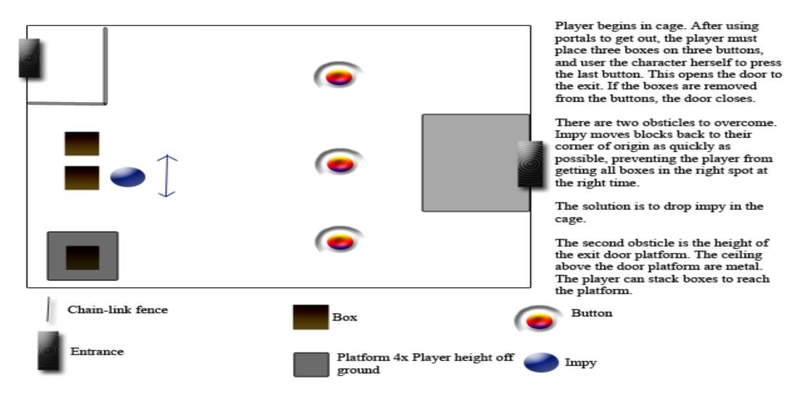

3.8.b Boulder Dash
This is the first room where the player will need to make portals on demand, as well as think creatively about how to pass obstacles using objects they've seen in the room..
Description – Three long hallways adjacent, followed by a lava pit and ending with two buttons in small boulder-sized pits which operate the exit door. Populated with a lava turtle, two boulders, and two buttons. There is a high ledge above the lava pit (as an alternate method of solving).
Obstacles – Dodge the boulders, cross the pit of lava, press the buttons.
Solutions – Use portals to pass the boulders to the room behind the player, then drop the lava turtle into the pit, and ride its back across. Use the boulders in the previous hallways to smash down both buttons. If both buttons are down simultaneously, the room is solved and the door opens.
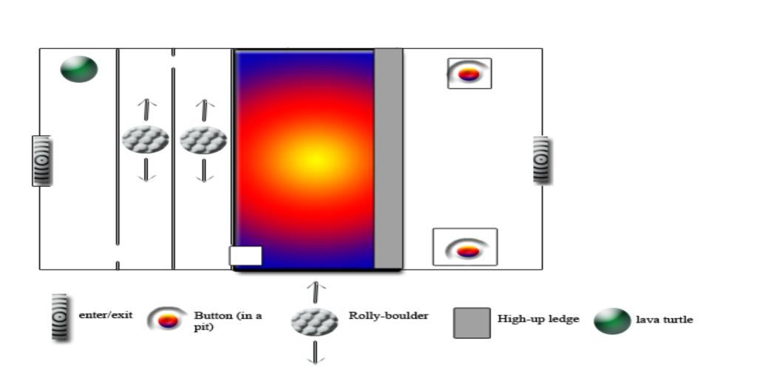
Hints – Upon entering, Wally describes the lava turtle by saying:
“Hey, a Lava turtle! Shouldn't it be in lava?”
If the player dies in lava, or 2 minutes pass and the player hasn't reached the button-side of the lava, Wally suggests using the lava turtle to cross. If 2 minutes pass after the player has reached the button-side of the lava and the no button has been pressed Wally suggests using the boulders to press both buttons simultaneously.

3.8.c Hallway to Hell
This medium-paced room requires more thinking than the others, as well as a little bit of timing and air-control skills.
Description – This 'q' shaped room has a stone platform, a lava pit full of lava and a lava turtle, adjacent to a stone platform, which is followed by an empty lava pit, a metal platform, around the corner from which is another lava pit (full, no turtle) with three pillars of increasing height. Across this final lava pit is the exit door, on a large metal platform.
Obstacles – First lava pit, second pit (with metal walls, and the metal platform across provides a challenge in crossing it), and third lava pit with the pillars are the three obstacles. This third lava pit has metal dividers hanging from the ceiling which occlude vision of the stone ceiling, preventing placing portals beyond the closest pillar's ceiling area.
Solutions – The first lava pit can be solved by riding the lava turtle. The second pit can be solved by placing a portal on the side of one pillar, facing the metal platform , and jumping off the taller pillar through the floor portal, and out the side portal across the chasm and onto the metal platform. The third lava pit can be crossed by placing portals on the ceiling and dropping down onto the pillars. From the last pillar, the stone ceiling of the metal exit platform can be seen, and a portal can be placed to drop down to the exit. Upon landing on the exit platform, the level is solved.
Hints – Wally will suggest the above solutions if the player has spent more than 2 minutes at any one stone platform. The solution suggested is determined by the obstacle in front of the player.
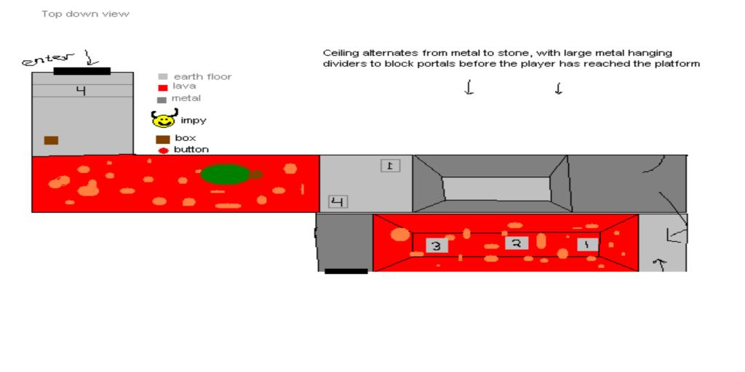

3.8.d Ledge Ladder
This is a vertical puzzle where the player dodges boulders on the way up to the exit. The final exit puzzle will require some thinking and an optional puzzle to shut off the boulder spawn will make the final exit portion easier.
Description – The player enters a tall square room, currently on the bottom. Ledges protrude from the corners, alternating clockwise until a final half-plane ledge at the top on which the exit lies. The ceiling is metal.
Obstacles – The metal ceiling has 9 boulder spawns, which each spawn a randomly directed boulder at reasonably slow intervals.
Solutions – To climb the ledges the player may place portals on the bottom of higher ledges and drop down, or on the walls above higher ledges and drop/walk through.
To stop the boulder spawn, a button on the 3rd highest ledge must be pressed using a box found on the ground level.
The ceiling is made of metal, so the final ledge cannot be reached by dropping down. It is too close to the ceiling to see a wall near the ledge. To reach the exit, the player must use the first portal on the wall across from the exit's ledge and jump down to the second portal. The velocity from the fall will carry through and fling the player on to the final ledge.
This will be extremely hard if the boulder spawn is not shut off.
The last few platforms are made of metal on the top, and absorb boulders as to make the bottom rung a save zone.

Hints – Wally will mention the button the first time the player reaches the button's ledge. The text should suggest pressing the button will stop the boulders.
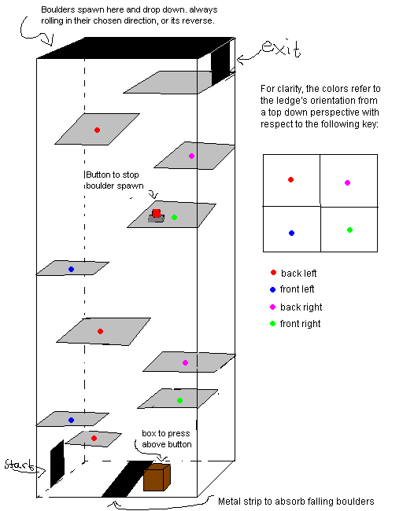

3.8.e Fire With Fire
This is the final room in the game. It's the boss battle showdown between No-knees and Demon. The player will need to have quick reaction in dodging and making portals. Demon walks back and forth along the back wall of the platform level he is on.
Description – The numbers below represent ascending height. The player and Demon start in height 1. Demon throws fireballs and summons boulders. Fireballs come out of the wall behind demon, and fly across the platform into the wall across from demon. The boulders come out of the floor of level four, and fall down the levels, and are absorbed in level 1's floor.
Obstacles – The player must dodge fireballs and boulders. Also, when the player and demon have both left a level, that level fills with lava.
Solutions – The player needs to use portals to hit Demon with his own fireballs and rocks. Each time Demon is hit, he falls down, then levitates up to the next platform level. The fireballs he summons always come from the level that No-Knees is currently on (so nowhere is safe). As soon as No-Knees moves out of a Demon-Vacated level, it fills with lava.
Hints – Every so often Wally will cheer on No-knees saying, “You've got to turn his weapons against him.”
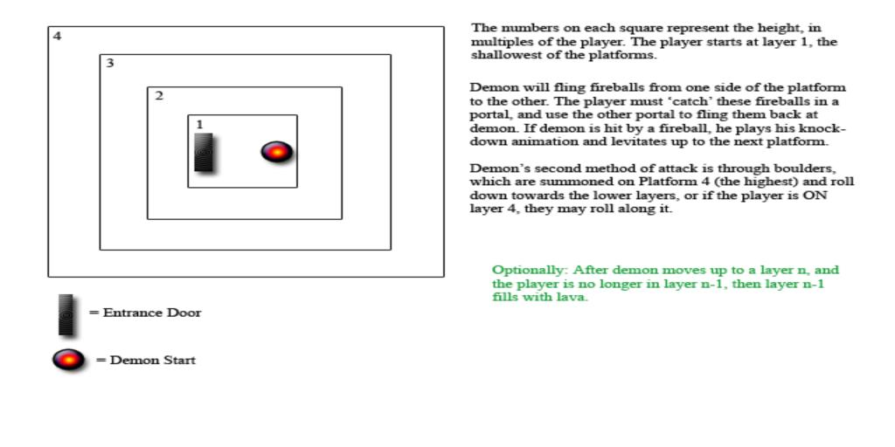

4. Descriptions

4.1 3D Models

Note: All objects below should be able to fit in a portal, i.e. Wally's mouth. Animations are listed with their feature priority A-Z.

4.1.a No-Knees
Up to 2000 polygons
512 x 512 texture
Scale is 1x1x1 meter cube

Walk forward - A
Walk Backward - A
Idle - A
Knock Down - A

Portal Summoning - B
Falling - B (Should be somewhat fearless about falling as there is no fall damage)
Strafing - B

Running into object - C
Dying in lava - C

Get up from floor - D (could be use for portal transitions)
Pull up from ledge - D (low chance of being seen)
Losing balance near ledge - D
Delayed Idle - D (After 20 seconds of no input, sits on ground or taps foot, or something)

The head is separate meshes from body so that we can rotate them to where the player is looking.

4.1.b Wally's Mouth
Up to 500 polygons
256 x 256 texture
scale is 2x2 meter box.
Animation needed for opening (it's reversed for closing).
Origin (0,0,0) is at the center of the mouth opening where it would attach to a wall.
Must have an opening large enough to fit a boulder.
This is just a frame that borders a portal, so it should not have a back in its opening.

4.1.c Demon
Up to 1000 polygons
512 x 512 texture
scale is at least 10x the size of no-knees.

Taking Damage – A
Dying - A
Walk - A
Idle - A

Summoning Object - B
Jump - B

Gloat - C (after he wins)

4.1.d Lava Turtle
Up to 500 polygons
256 x 256 texture
Scale is a 1.5x1.5x1.5 meter cube.
Swim - A
Idle/Flail - A

4.1.e Impy
Up to 1000 polygons
512 x 512 texture
scale is a 1x1x1 meter cube

Walk - A
Idle - A (we'd like it to involve sweeping w/ broom)
Lift and Carry - A
Block Portal - A

Run - B
Polish - B
Falling - B (he can be very upset about falling cause it will never be by his own choosing)
Climbing - B

Knocked down - C
Tantrum - C

Jump - D (jump for length, it'll be across chasms and such)
Taunt - D (point and scream, cuss, etc)

See section 3.5 for game play specific details on Impy.

4.1.f Metal Crate
Up to 50 polygons
256 x 256 texture (repeats on all sides)
2x2x2 meters cube in size (this makes scaling the easiest).

4.1.g Button
Up to 30 polygons
256 x 256 texture
scale is about half the height of no-knees, and similar in girth.
2x2 meters and rests slightly above the ground when depressed. When pressed it is level with the ground.
Origin (0,0,0) is at the center of the button where it would attach to the ground.

4.1.h Boulder
Up to 100 polygons
256 x 256 texture.
2x2x2 meters scale

4.1.i Wall Torch
Up to 30 polygons
128x128 texture.

4.2 Textures

4.2.a Room Geometry
All room geometry also has a gray scale bump map that is the same dimensions as the texture.

Dirt walls – Three 512x512 with vines/roots for variation
Dirt floor – Two 512x512
Dirt ceiling – 512x512
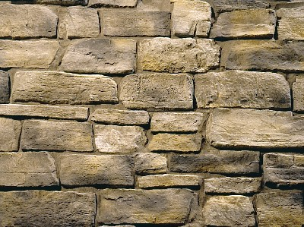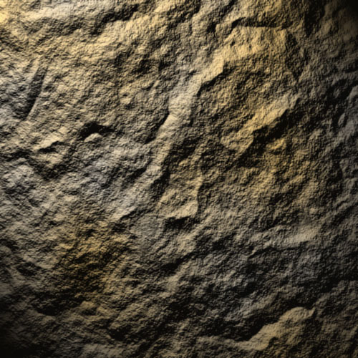

Concrete Texture – 512x512


Chain link fence – 265x256
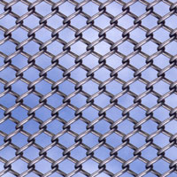

Metal plating – 256x256
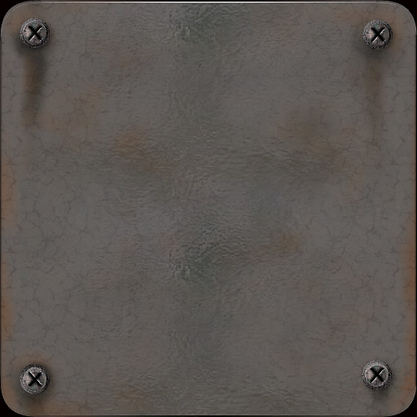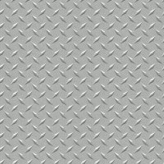

Lava – 256x256
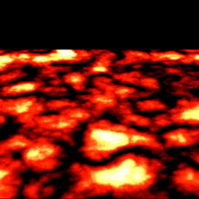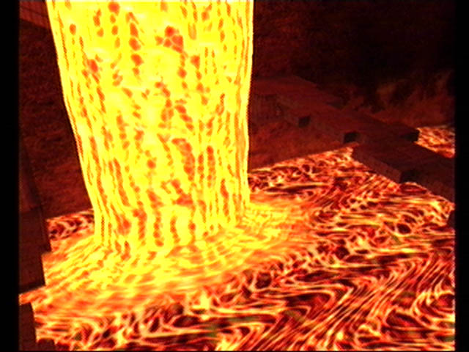

4.2.b Particles
All particles are 32bit (rgba) and contain an alpha channel for transparency.

Steam – 256x256
Dust – 256x256
Demon fireball – 256x256
Torch flames – 256x256

4.3 Audio

4.3.a Music
Possibly somewhere between classical and jazz using timpani, synth strings, and organ. There should be songs for the following:
Title Screen/Menus – Creepy, alien synthed.
Rooms – Long and mellow, still creepy.
Final Room (boss battle) – Intense.
Credits – Happy fanfare.

We will create this music ourself.

4.3.b Sound Effects
For the most part, canned sound effects will work. Here's a list of what's needed:
No-knees – Walking on ground, walking on metal, walking on chain link, falling, hitting the ground, running into chain link, running into an object, and dying.
Wally – Portal opening, rejecting portal and speaking, voice will be synthesized and sound similar to whale calls.
Demon – Summoning, getting hit, roar, jump/thud and dying.
Imp – Some kind of impish cackle, running sounds, panting, picking up box.
Misc – Crate sliding, crate hitting the ground, boulder rolling, boulder hitting the ground, button being pressed, button being depressed, door opening/closing, door slamming shut, lava flowing, torch flicker, door opening, portal opening/portal closing, Door-open chime, Secret acquired chime and lava solidifying.

4.4 Special Sequences

4.4.a Credits
We'll decide what this should be over the course of the project (like usual). It's just being mentioned that there needs to be a credits sequence. At the very least this is scrolling text. This probably wouldn't make sense as interactive credits, but something thematic to portals would be cool.

5. Sign-Off

Product Manager
Jeep Barnett _______________________________________________________

Technical Director
Dave Kircher _______________________________________________________

Designer
Garret Rickey _______________________________________________________

Producer
Lead Artist
Kim Swift _______________________________________________________

Art Team Lead
Scott Klintworth _______________________________________________________

Artist
Realm Lovejoy _______________________________________________________

Artist
Paul Graham _______________________________________________________

Artist
Eric Brown _______________________________________________________

