Narbacular Drop Postmortem

What went right?

Simple focused concept.
Every year we tried to do a simpler game than the last. We built the game around one specific feature. We refined the design over and over until we had nothing but gameplay and polish. Keeping content to a bare minimum was key for such a small project.

Everything worked like we planned.
We took our past DigiPen failures and learned from them. Very early we evaluated every technical and gameplay issue we could be faced with. We brainstormed the best solutions and several back up plans. Having the overall vision of how to complete the project let us build components that fit nicely together.

It got us jobs.
We wanted this project to be the centerpiece of our portfolios. We set aside time make the project accessible to future employers and 'swank'. It succeeded in getting us job offers as well as our entire team an offer from Valve.

What went wrong?

Communication barriers between the programmer and art teams.

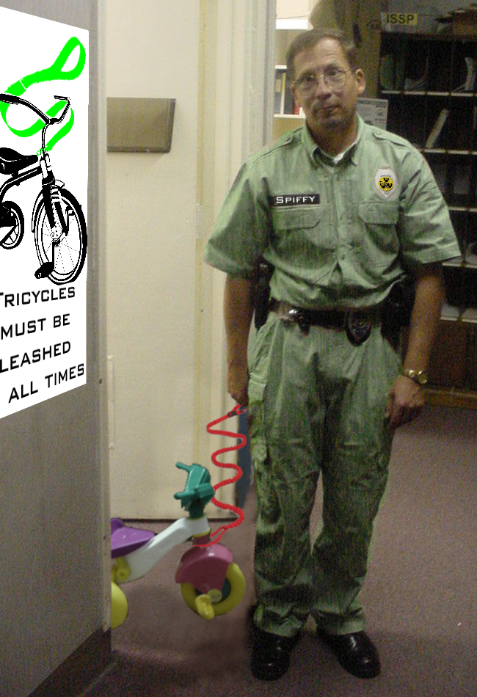
Programmers and artists are kept much too isolated at DigiPen and it hurt us initially. Artists are set up as contractors for the programmers and this hurt the open team dynamic that we wanted. Programmers and artists were literally locked out of each others rooms and had restricted access to necessary asset database tools. Lack of interaction experience on both sides lead to miscommunications. We forced open all possible forms of communication (with some IT wrangling) to narrow the gap between us.

We didn't plan enough for physics.
Our game ended up needing more physics than we had originally planned for. Our simple physics engine breaks down under extreme cases (which became common by the nature of the game). Collision and physics should have been merged into one more robust system.

Spiffy McGee was a real drain on the team.
He was frequently absent, failed to complete tasks on time, and took a huge tole on moral.

