Narbacular Drop
Vertigo... Sideways... and Upside-down

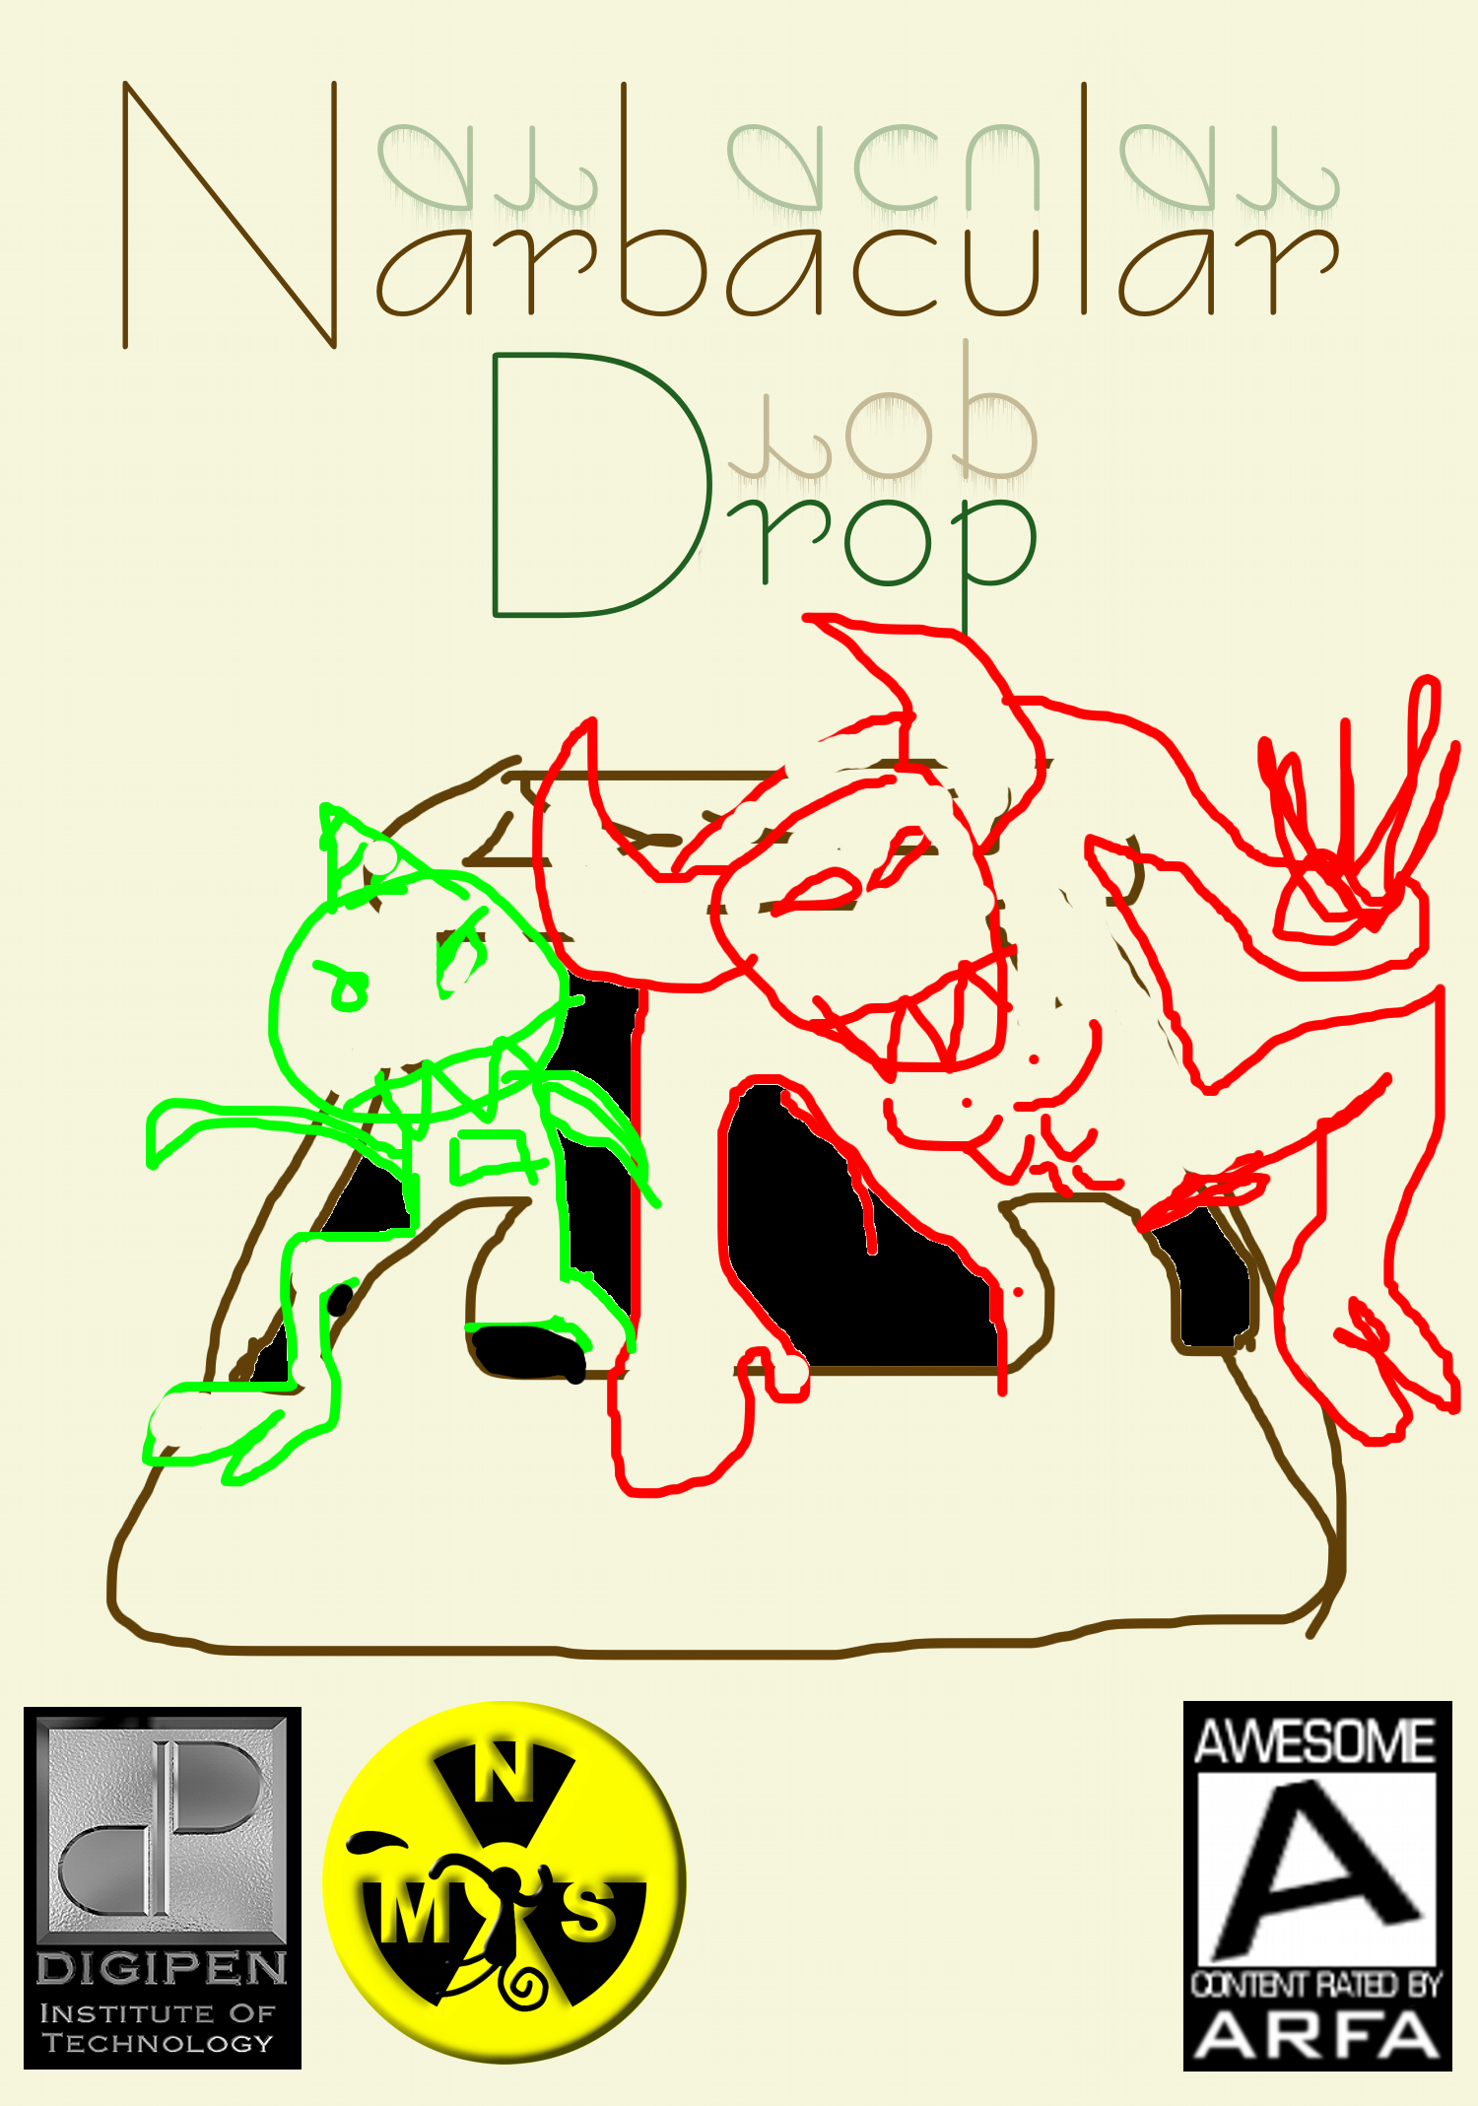
Narbacular Drop by Nuclear Monkey Software
Fantasy Action Puzzler
PC CD-ROM
Publication Date: April 22, 2005
5 Levels
Price: FREE
Size: 5” x 7” (~50MB)

Available from DigiPen
To download vist...
http://www.nuclearmonkeysoftware.com
http://www.digipen.edu

Narbacular Drop delivers a unique innovative experience that is the most unforgettable of any recent video games. The player will use the ability to place interlinked portals anywhere in an environment to overcome obstacles and solve puzzles. The seamless visual style and use of these portals is unlike anything ever before seen in a game. At the same time the unusual gameplay is presented with an interface intuitive enough for novice players to grasp. It also features cast of colorful characters to interact with.

Crafted by an enthusiastic team of aspiring developers, this game is a must have for the true gamer in you. You'll be blissfully surprised by the new realm of 3D space unlocked by its sincere simplicity. Interesting challenges lurk around every corner and the end of the game is only the beginning of sharing it with your friends.

“Well that's certainly the most unique thing I've ever played...”
Bobthecow

Marketing: $15 Marketing Budget. Independent Games Festival and The Big Bawls Independent Game Competition submission. Publicity stunts.

Nuclear Monkey Software is a student team of 4 programmers and 4 artists (Jeep Barnett, Dave Kircher, Garret Rickey, Kim Swift, Eric Brown, Paul Graham, Scott Klintworth, Realm Lovejoy). Their previous games include Gun-Fu: Disco of Crime and Desert Derby: Sexiness Run Rampant. They develop their games at the DigiPen computer labs in Redmond, Washington (across the street from Nintendo).

